**Logbook[1]Rohmat Dasuki**

|  |  |
| --- | --- |
| JURUSAN: TEKNIK KOMPUTER & INFORMATIKA | PROGRAM STUDI: D3  TEKNIK INFORMATIKA |

|  |  |
| --- | --- |
| Hari/Tanggal: | Selasa, 13,14,19 Februari2018 |
| Tugas | Explore Odoo dengan menggunakan guide e-book yang di berikan |
| Hari dan rentan pengerjaan | Selasa, 13 Februari 2018 - Minggu, 18 Februari 2018 ( rentan pengerjaannya ) |
| Tools yang digunakan | Odoo 10,0  Postgre SQL  Working-with-Odoo-10-Second-Edition.docx |
| Hasil Kerja | Chapter 2 : Installing your first application  Chapter 3 : Exploring Customer Relationship Management in Odoo 10 |
| Keterangan |  |
| Komentar manajer |  |

Create CUSTOMERS

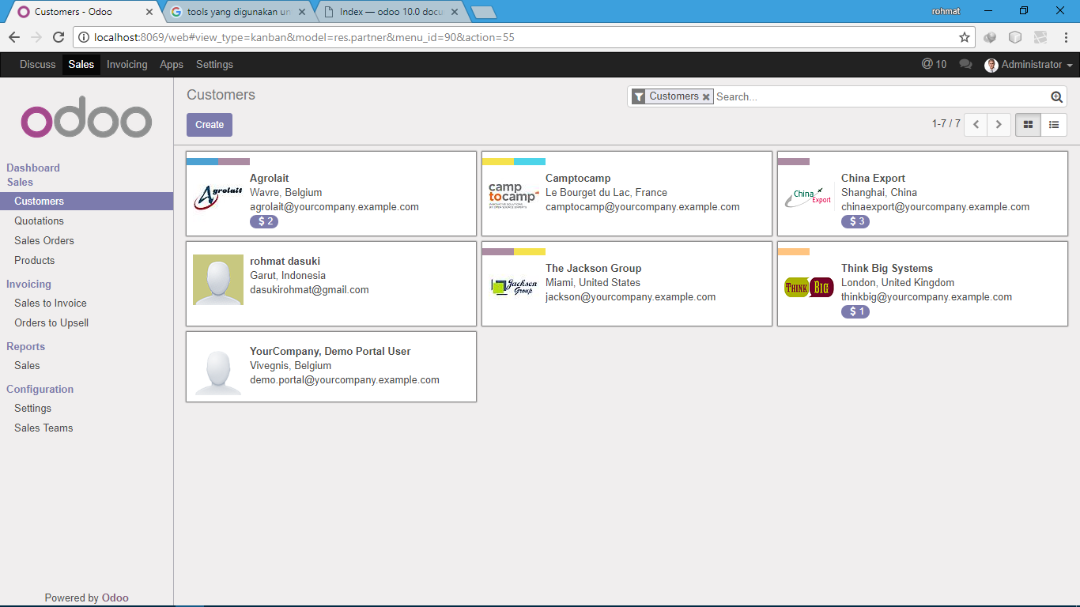

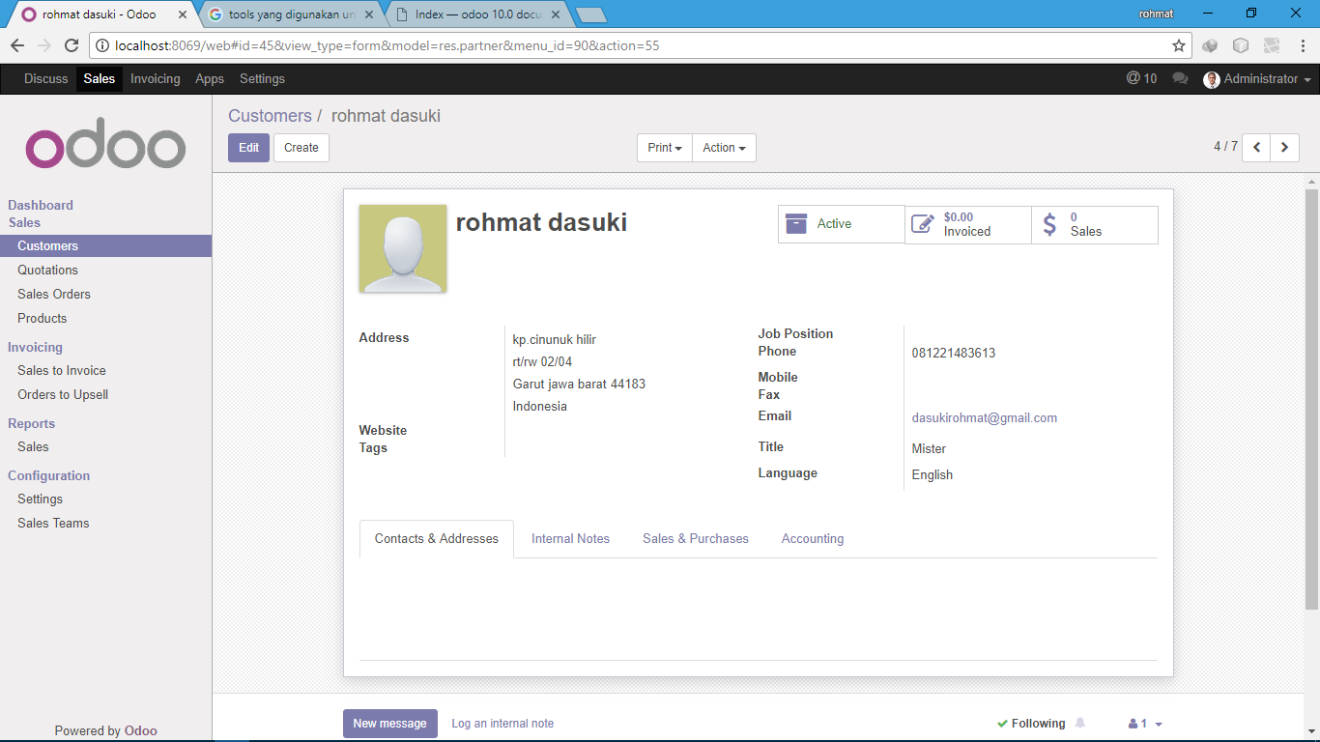

Create PRODUCT

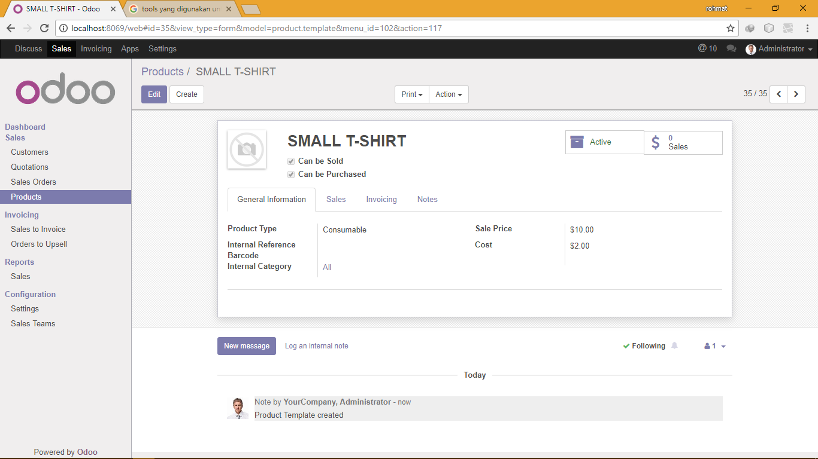

Setting Company Information

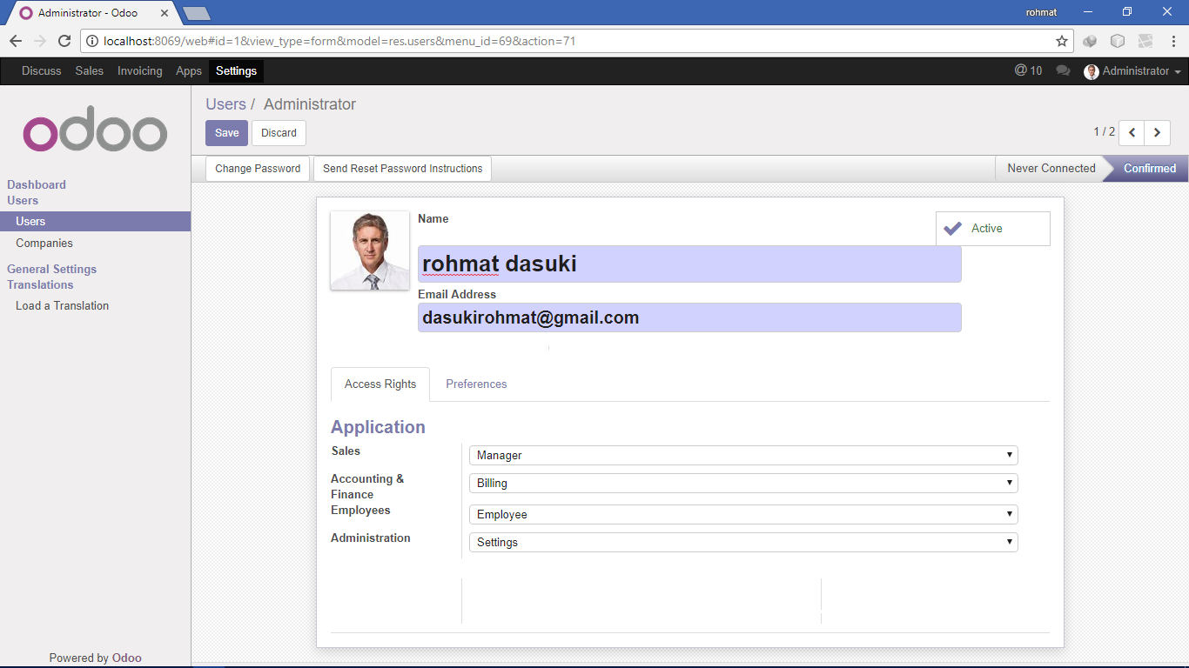

Entering sales order

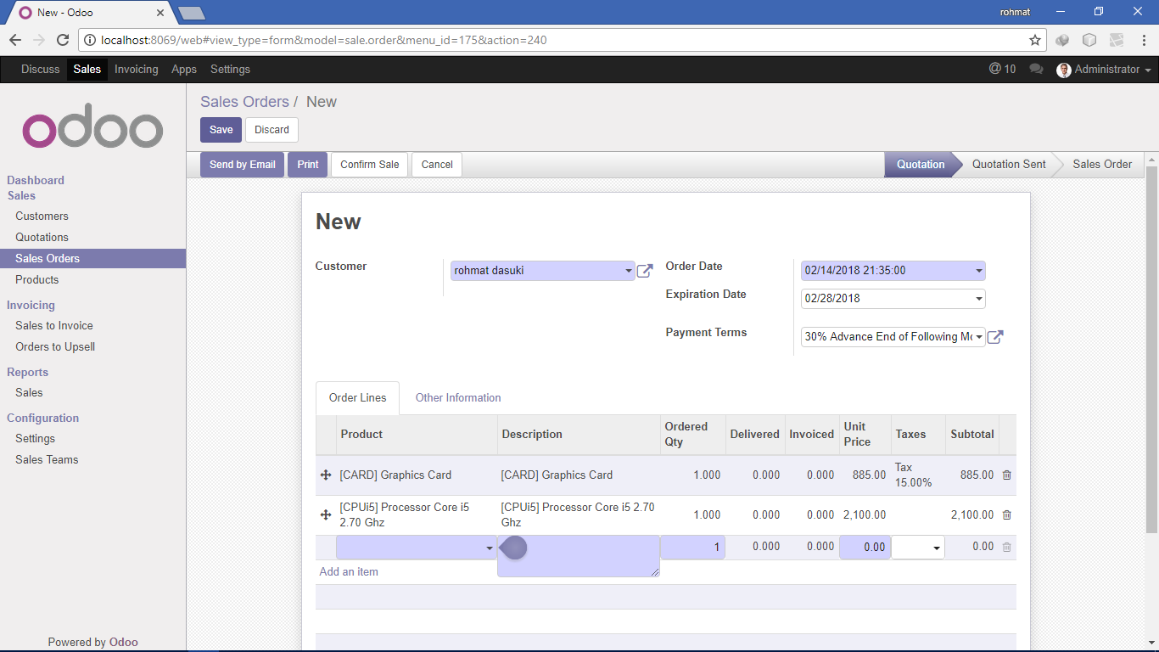

Assigning the sales representative or account manager 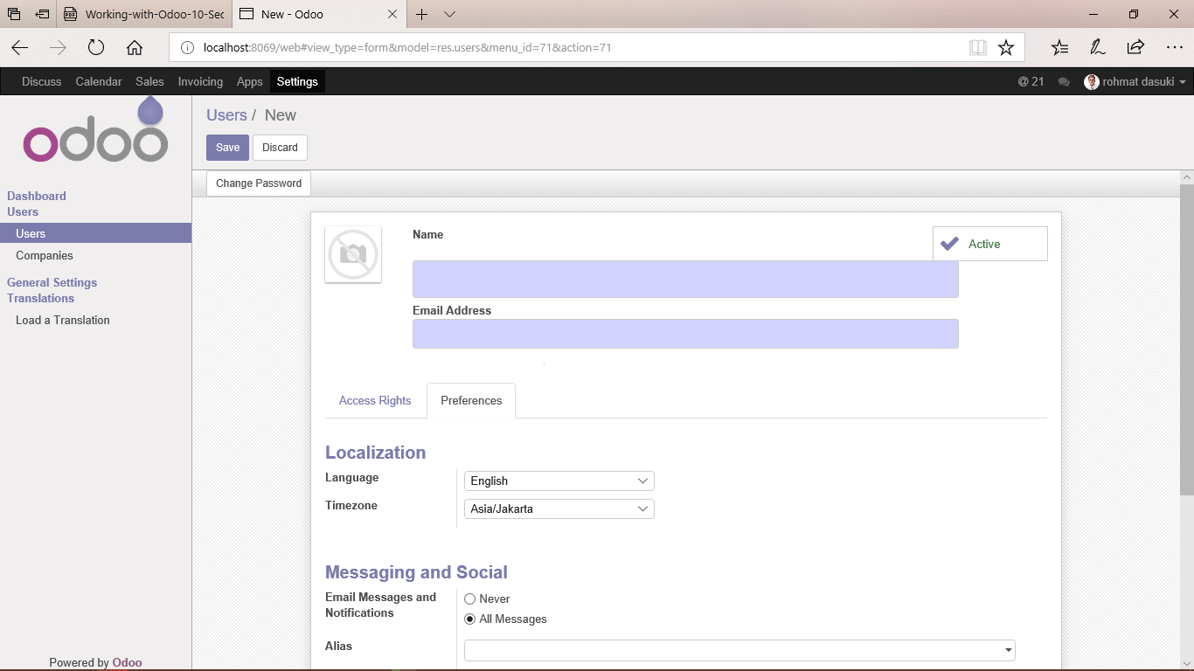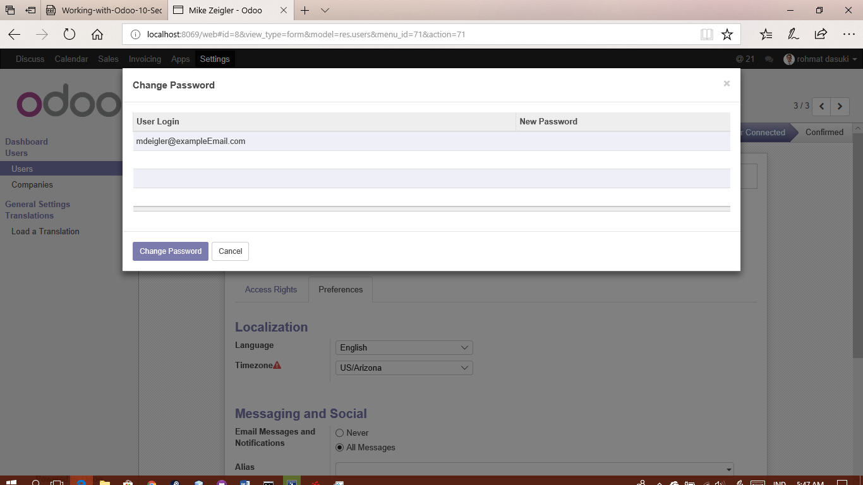

Assigning a salesperson to a customer

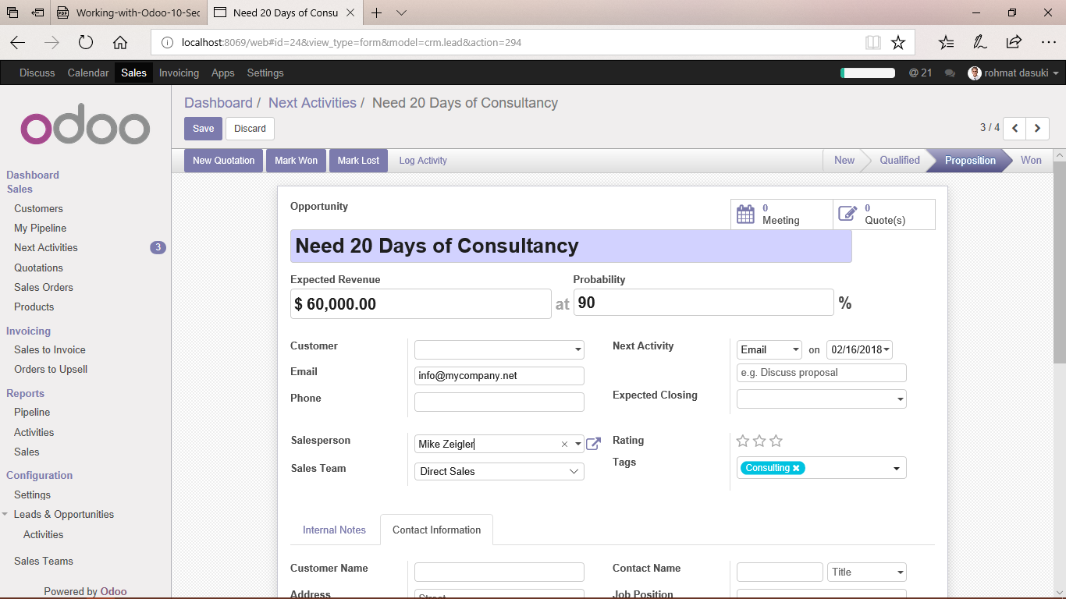

Understanding Your Pipeline

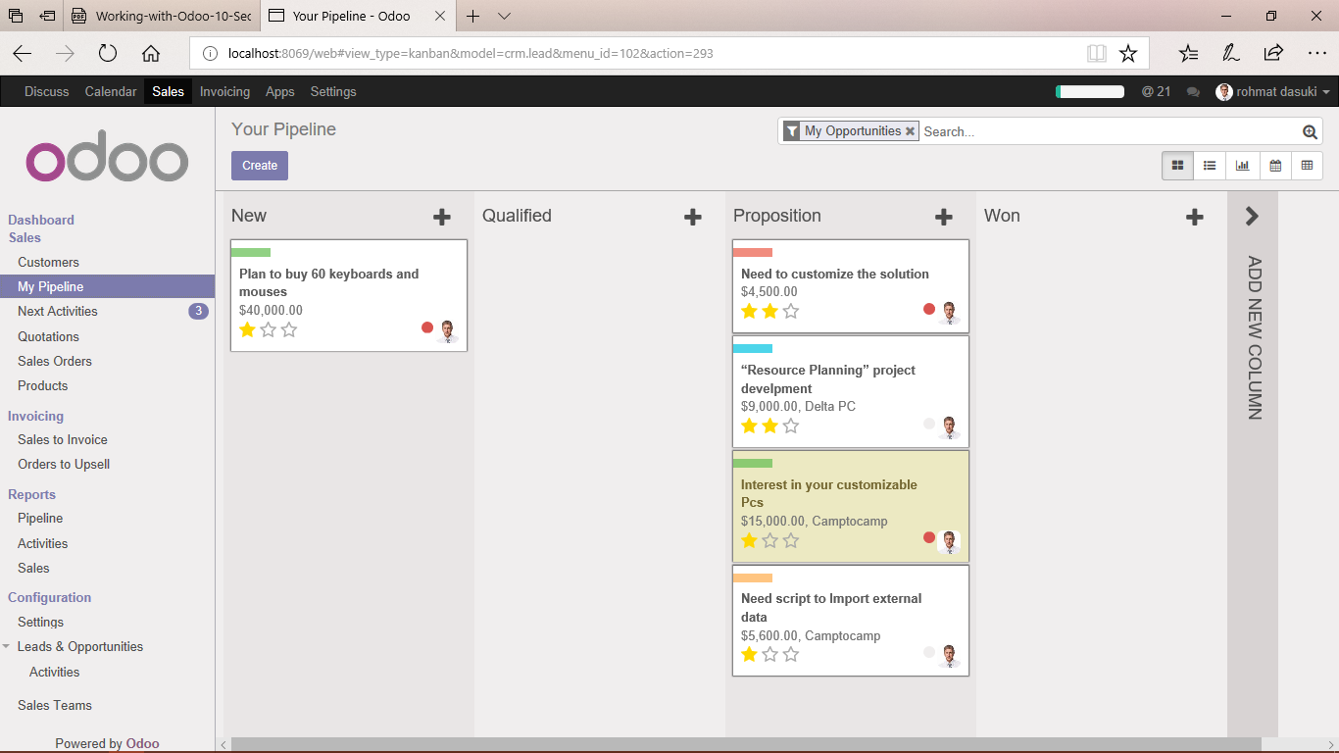

Creating a new opportunity

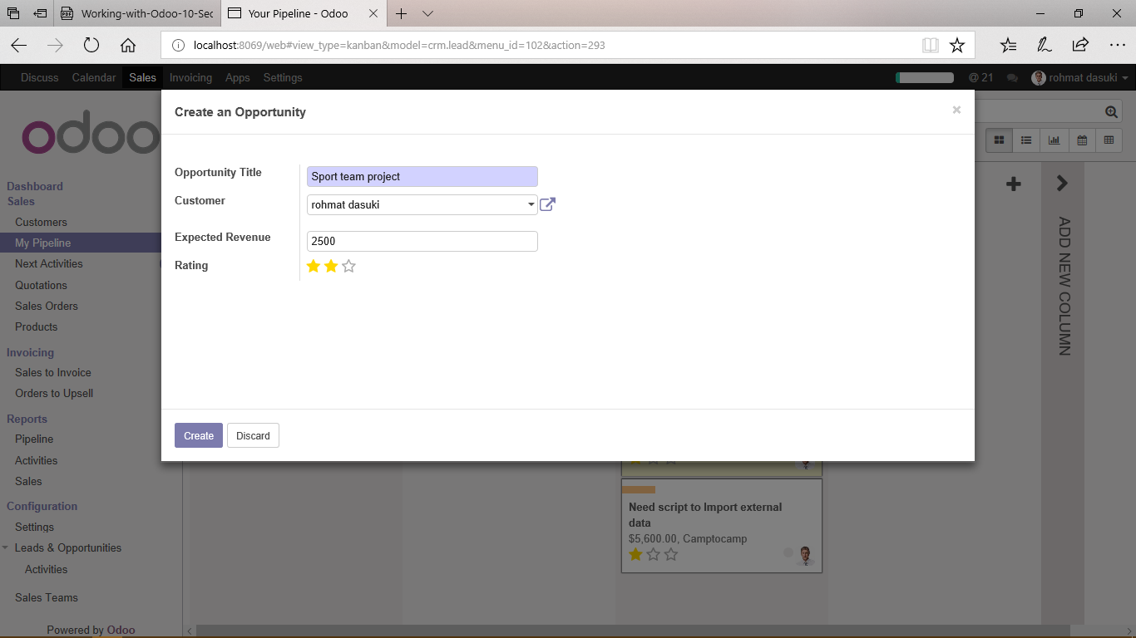

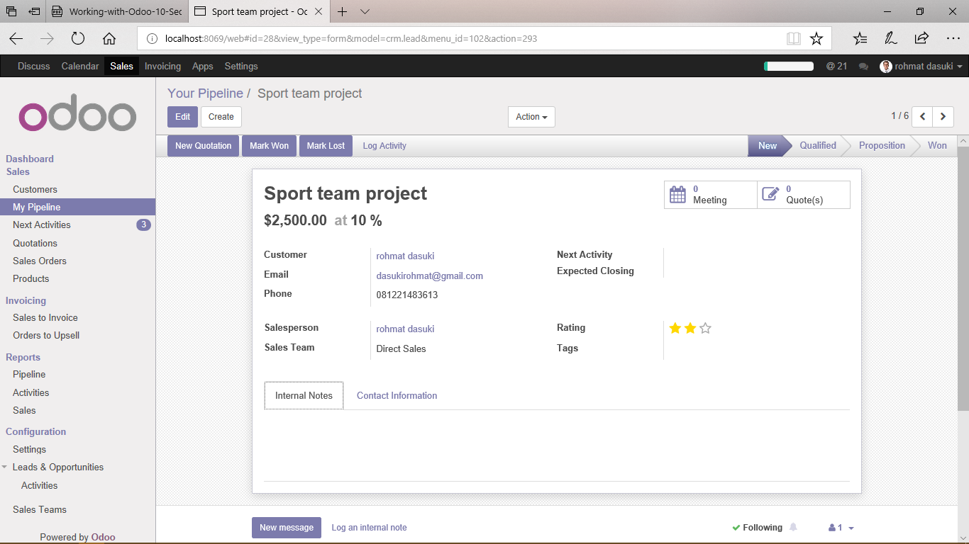

Looking at opportunities in your pipeline

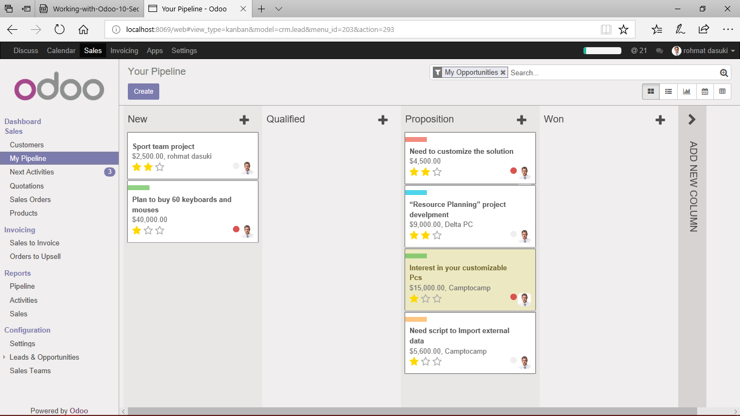

Edit pipeline

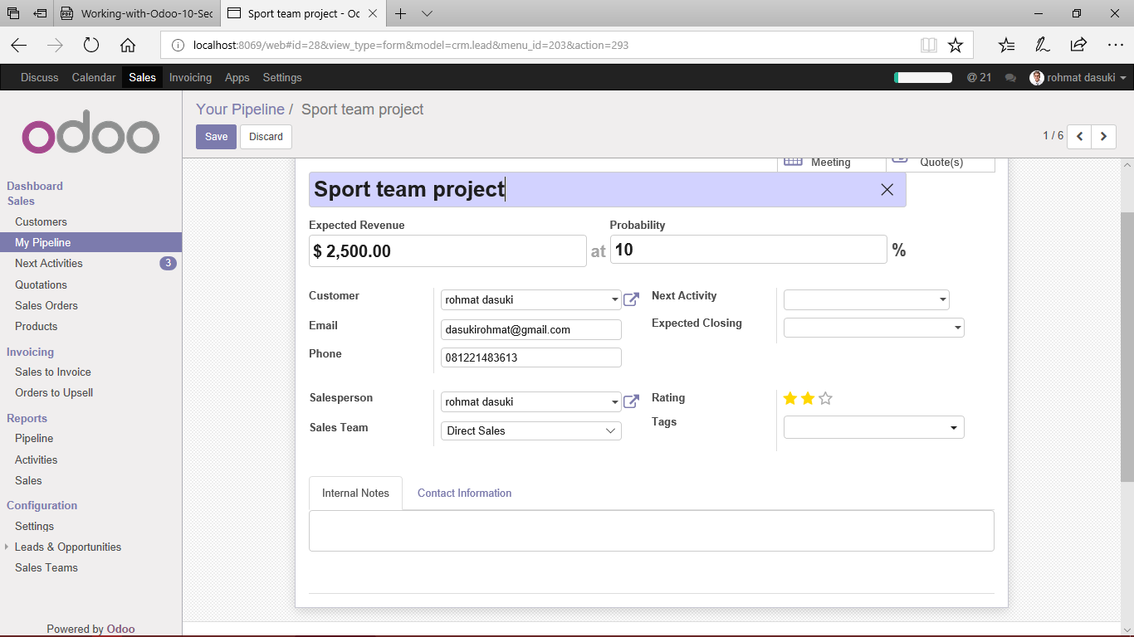

Contact information page

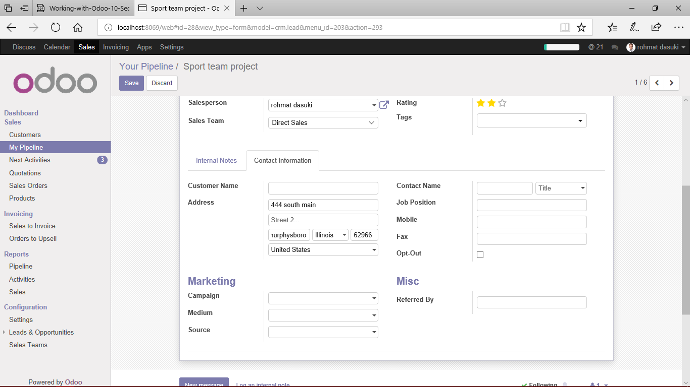

Changing the status of an opportunity

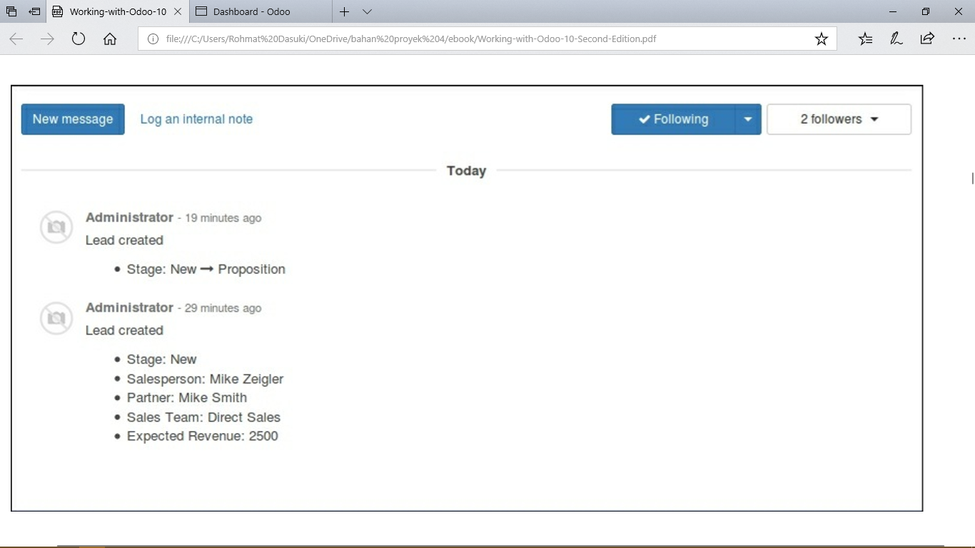

Managing the Opportunity

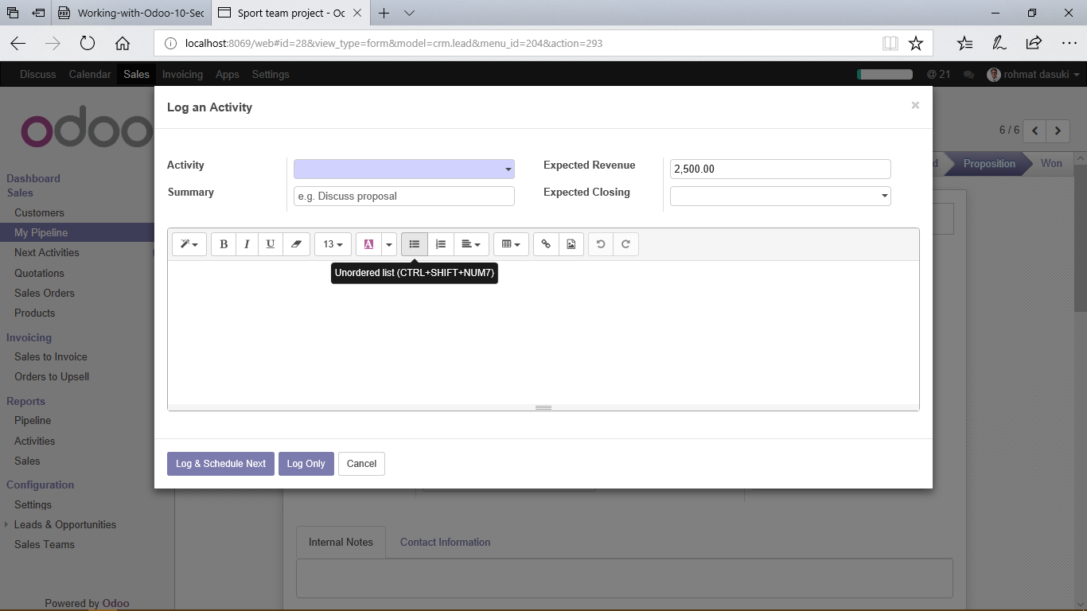

Turning on Leads in Odoo 10

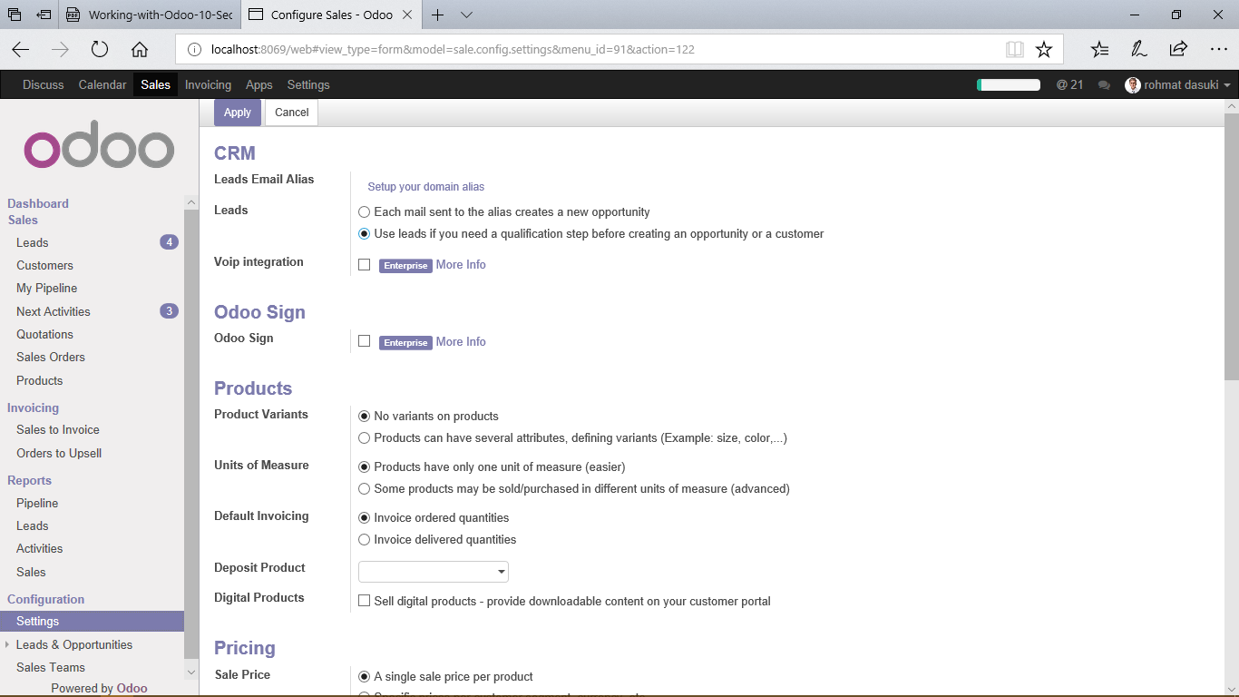

Creating Leads in Odoo

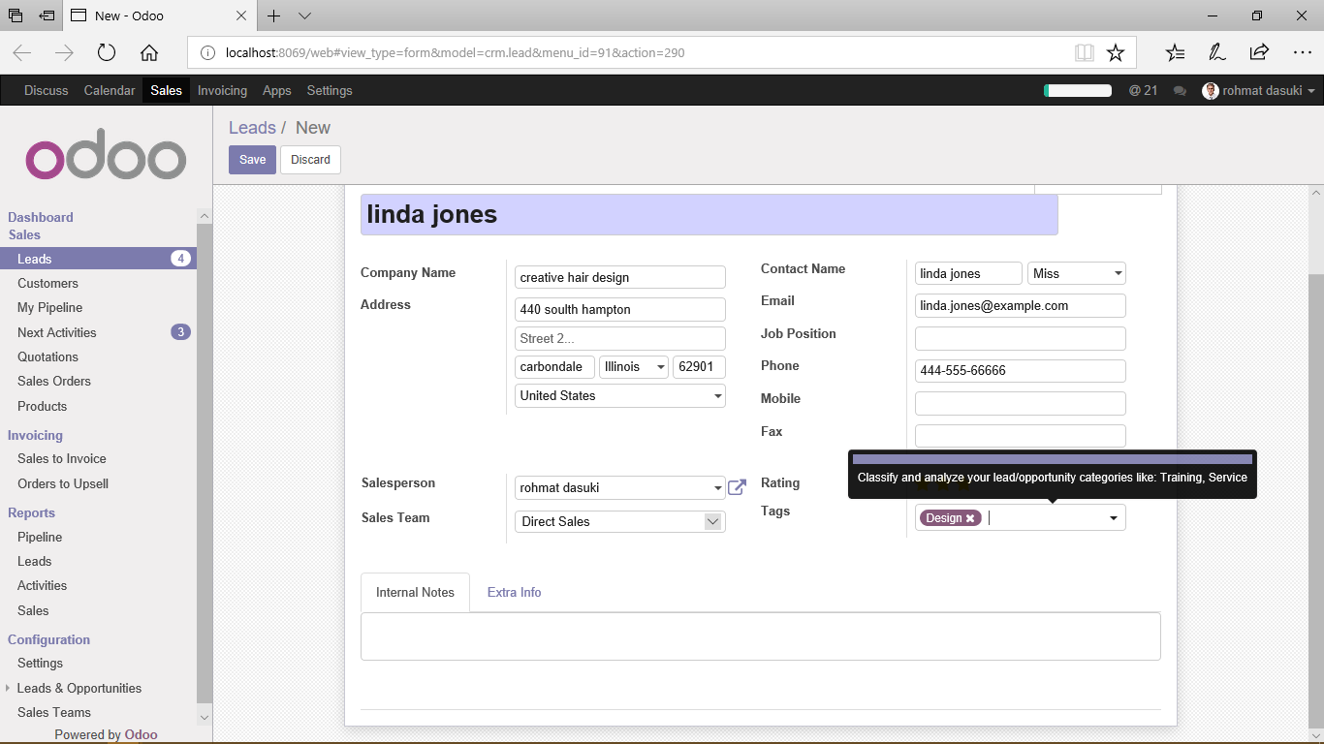Converting a lead into an opportunity

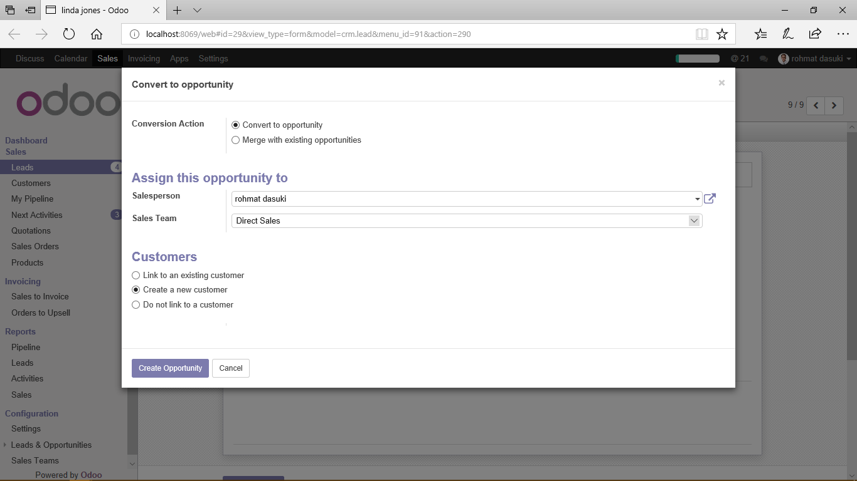

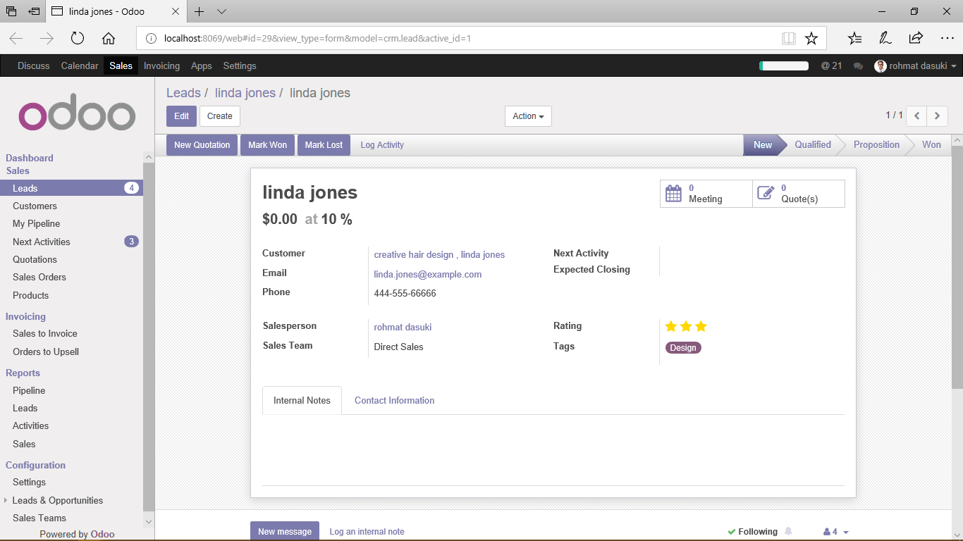

Using Odoo to schedule calls, meetings, and events

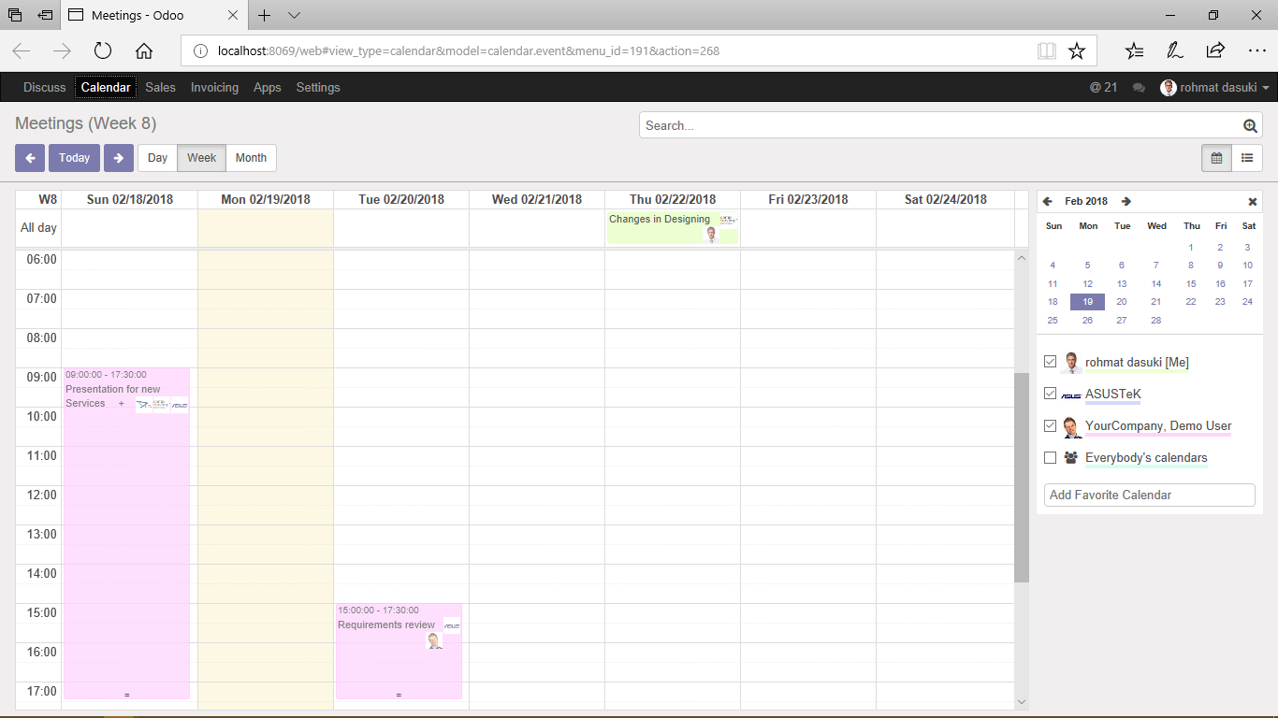

Scheduling an event

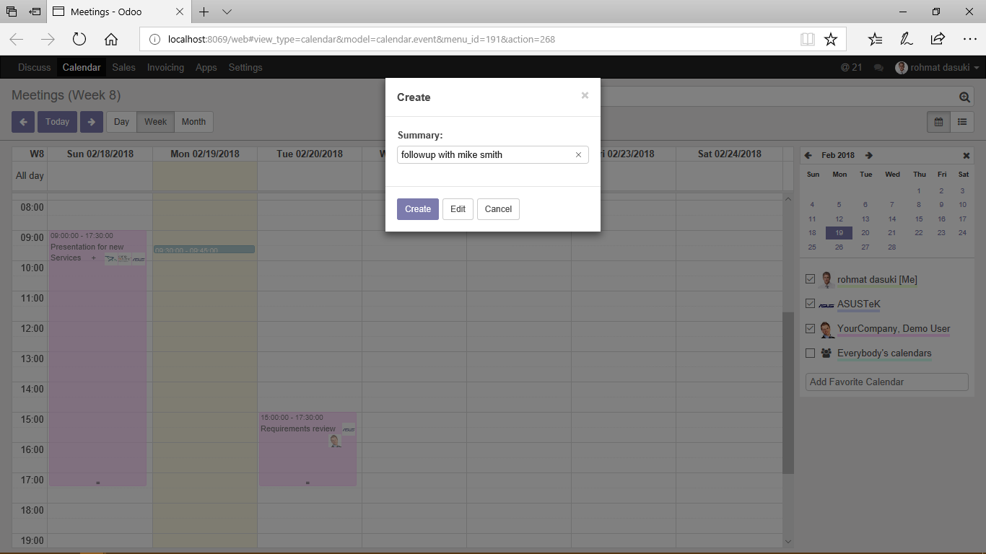

Click edit

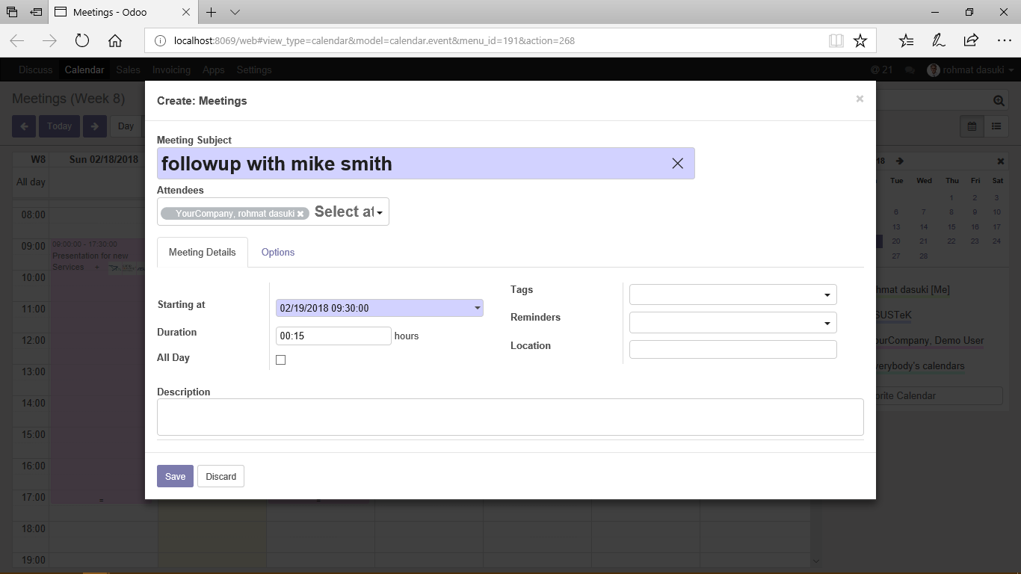

Adding attendees to your meeting

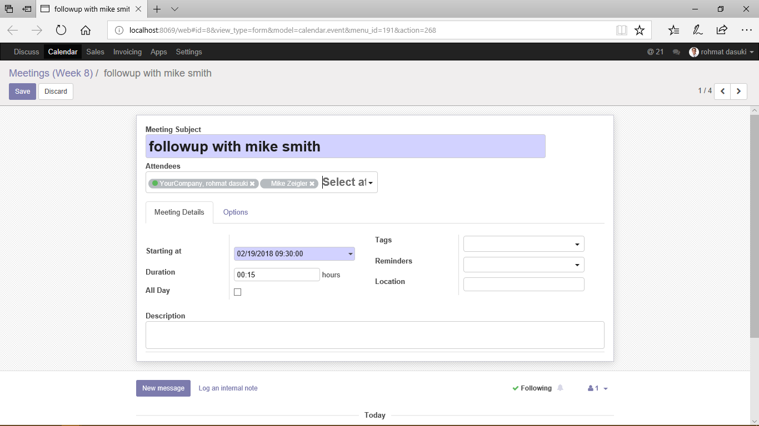

Specifying meeting details

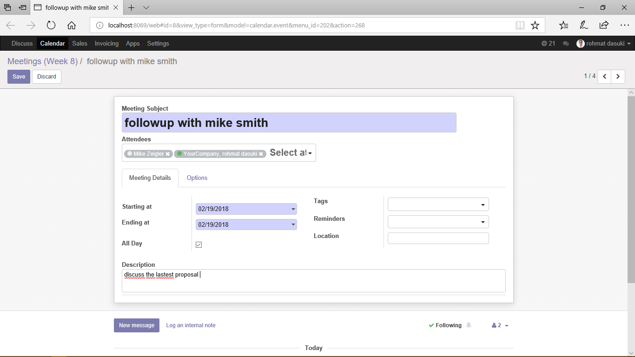

Specifying tags for your meeting

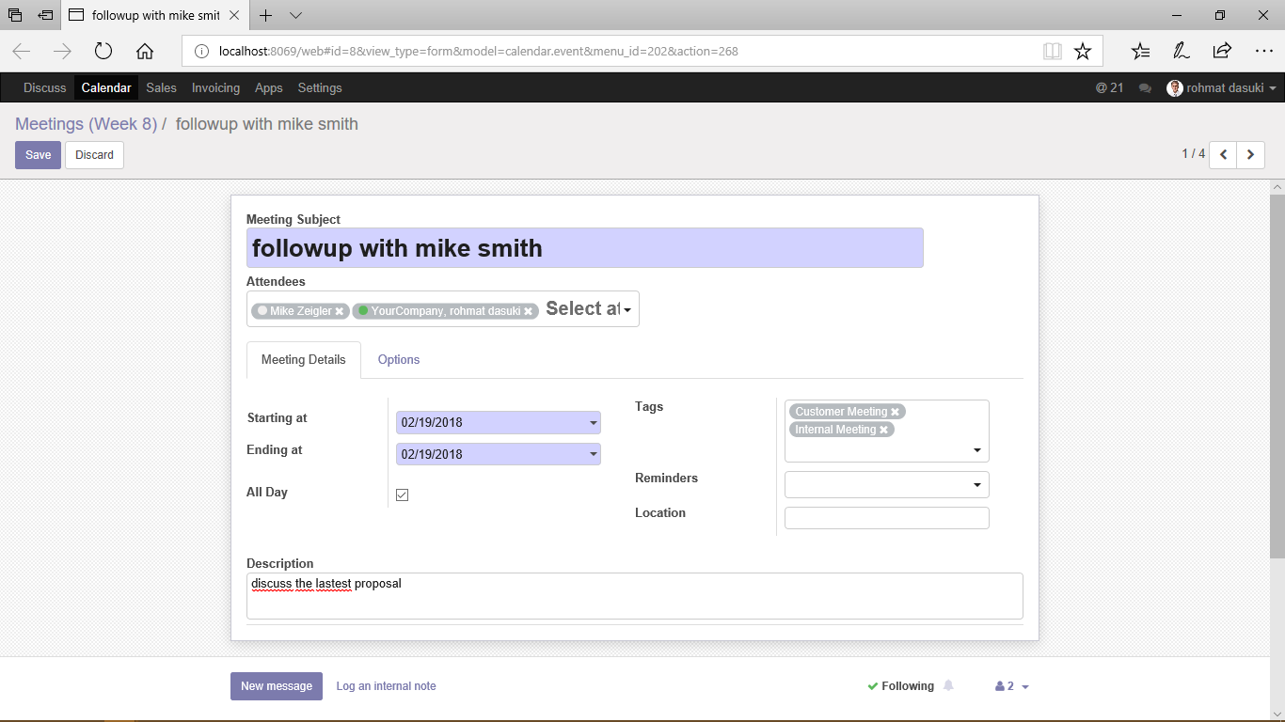

Setting up reminders for your meeting

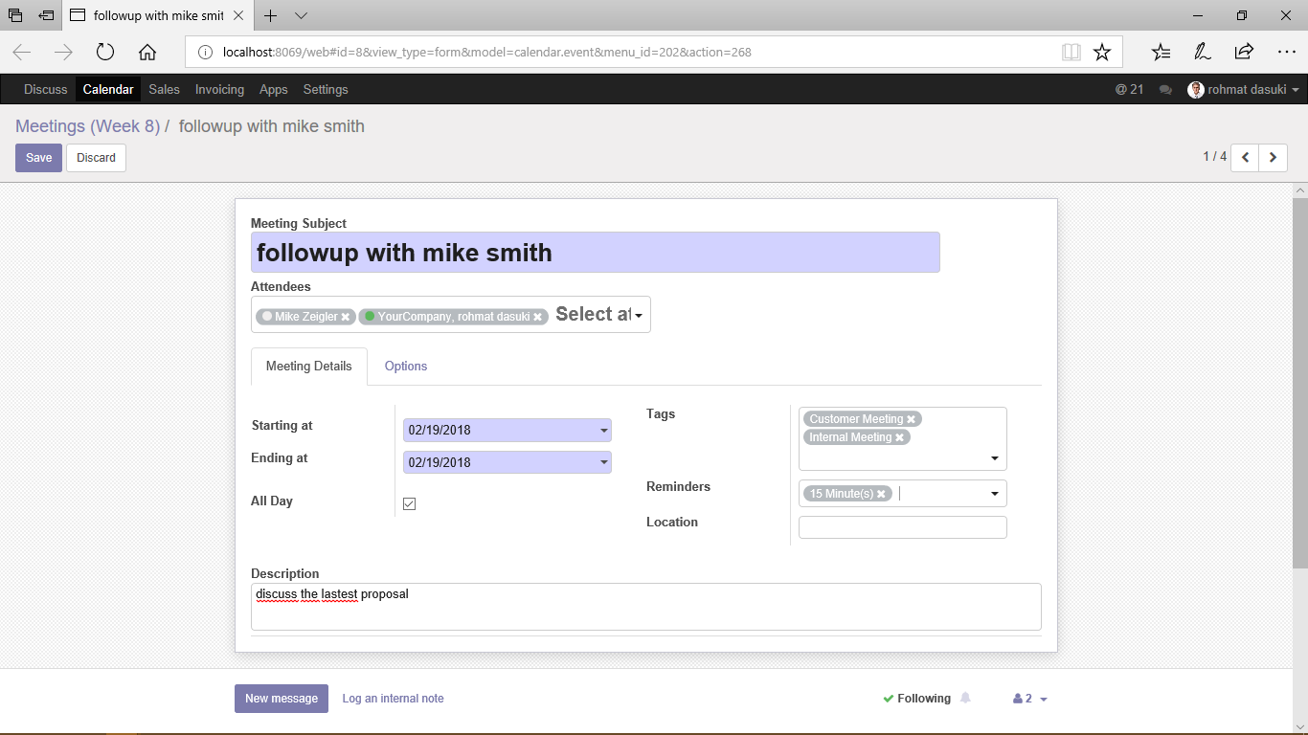

Specifying additional meeting options

